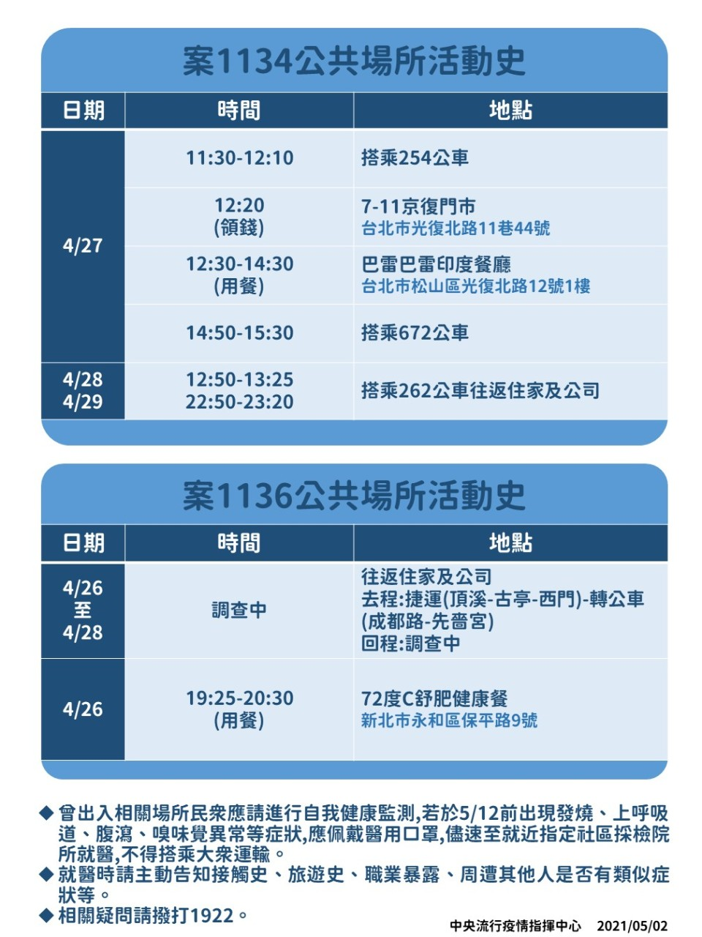

Activity trajectory of Case 1134
Date | Time | Venue
April 27th | 11:30-12:10 | Taking bus 254
 | 12:20  (Money withdrawal) | 7-11 Convenience store  No. 44, Ln. 11, Guangfu N. Rd., Songshan Dist., Taipei City
 | 12:30-14:30  (Dining) | Balle Balle Indian Restaurant  1F., No. 12, Guangfu N. Rd., Songshan Dist., Taipei City
 | 14:50-15:30 | Taking bus 672
April 28th  April 29th | 12:50-13:25  22:50-23:20 | Taking bus 262 between home and company
If you have ever been to the places listed above, please immediately inform the University Health Center and implement self-health management until May 12th.

Activity trajectory of Case 1136
Date | Time | Venue
April 26th - April 28th | (Investigating) | Between home and company  Forth: MRT (Dingxi – Guting – Ximen) and Bus (Chengdu Road – Xianse Temple)  Back: Investigating
April 26th | 19:25-20:30  (Dining) | 72°C Healthy Meal Restaurant  No. 9, Baoping Rd., Yonghe Dist., New Taipei City
If you have ever been to the places listed above, please immediately inform the University Health Center and implement self-health management until May 12th.

